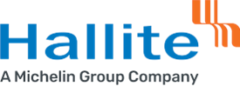

**Health, Safety and Environmental Policy**

The Hallite Seals Americas, LLC. - Wixom Facility and its associates are committed to the development, operation and continual improvement of our Health, Safety and Environmental systems by:

* Complying with all relevant Health, Safety and Environmental laws and regulations, and other requirements.
* Committed to creating a culture of continual improvement through leadership, training, participation and consultation.
* Working to prevent injury and ill health within the workplace.
* Operating and maintaining equipment, facilities and processes in a safe manner.
* Preventing pollution at the source wherever and whenever possible.

This policy is made available as required to all interested individuals or groups.

***Mike Baxter- Managing Director***

***Hallite Seals Americas, LLC.***

***Wixom Facility***

***August 2024***