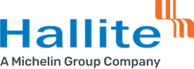

Quality Policy

The Hallite Seals Americas, LLC. - Wixom Facility and its associates are committed to the development, operation and continual improvement of our Quality Policy by:

We are committed to continuously improving quality by:

- Provides quality objectives.
- Commitment to satisfy applicable requirements.
- Continual improvement of the HOS systems.
- Supports strategic direction.

This policy is made available as required to all interested individuals or groups.

Mike Baxter- Managing Director
Hallite Seals Americas, LLC.
Wixom Facility
August 2024

