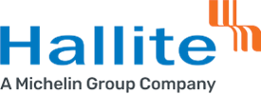

Health, Safety and Environmental Policy

The Hallite Seals Americas, LLC. - Wixom Facility and its associates are committed to the development, operation and continual improvement of our Health, Safety and Environmental systems by:

- Complying with all relevant Health, Safety and Environmental laws and regulations, and other requirements.

- Committed to creating a culture of continual improvement through leadership, training, participation and consultation.

- Working to prevent injury and ill health within the workplace.

- Operating and maintaining equipment, facilities and processes in a safe manner.

- Preventing pollution at the source wherever and whenever possible.

This policy is made available as required to all interested individuals or groups.

Ravila Moodley- Managing Director
Hallite Seals Americas, LLC.
Wixom Facility
April 2025

